### ­­­­­

### Semester Two Examination, 2018

### Question/Answer booklet

# MATHEMATICS METHODS

**UNIT 1 AND 2**

## Section Two:

## Calculator-assumed

Name: _______________________________________________________

Teacher’s Name:_______________________________________________

## Time allowed for this section

Reading time before commencing work: ten minutes

Working time: one hundred minutes

## Materials required/recommended for this section

***To be provided by the supervisor***

This Question/Answer booklet

Formula sheet (retained from Section One)

***To be provided by the candidate***

Standard items: pens (blue/black preferred), pencils (including coloured), sharpener, correction fluid/tape, eraser, ruler, highlighters

Special items: drawing instruments, templates, notes on two unfolded sheets of A4 paper, and up to three calculators approved for use in this examination

## Important note to candidates

No other items may be taken into the examination room. It is **your** responsibility to ensure that you do not have any unauthorised material. If you have any unauthorised material with you, hand it to the supervisor **before** reading any further.

|  |  |  |  |
| --- | --- | --- | --- |
| **Question** | **Mark** | **Question** | **Mark** |
| **7** |  | **12** |  |
| **8** |  | **13** |  |
| **9** |  | **14** |  |
| **10** |  | **15** |  |
| **11** |  |  |  |
|  |  | **TOTAL** |  |

**Structure of this paper**

|  |  |  |  |  |  |
| --- | --- | --- | --- | --- | --- |
| Section | Number of questions available | Number of questions to be answered | Working time (minutes) | Marks available | Percentage of examination |
| Section One:  Calculator-free | 6 | 6 | 50 | 50 | 33 |
| Section Two:  Calculator-assumed | 9 | 9 | 100 | 100 | 67 |
|  |  |  |  | **Total** | 100 |

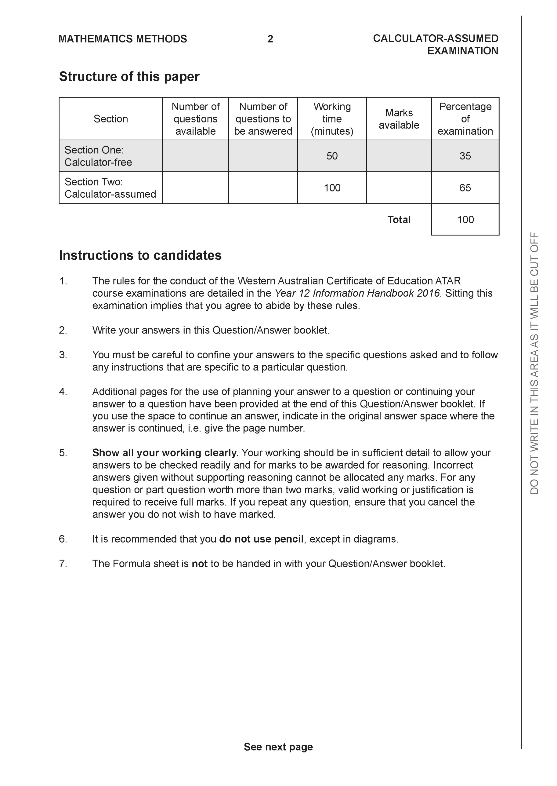

**Section Two: Calculator-assumed (100 Marks)**

This section has **8** questions. Answer **all** questions. Write your answers in the spaces provided.

Spare pages are included at the end of this booklet. They can be used for planning your responses and/or as additional space if required to continue an answer.

● Planning: If you use the spare pages for planning, indicate this clearly at the top of the page.

● Continuing an answer: If you need to use the space to continue an answer, indicate in the original answer space where the answer is continued, i.e. give the page number. Fill in the number of the question that you are continuing to answer at the top of the page.

Working time: 100 minutes.

**Question 7 (10 marks)**

A circle is centered at and has radius 13.

1. Find an equation for this circle. (2 marks)

|  |
| --- |
| **Solution** |
|  |
|  |

The straight line with equation intersects the circle at the points and and thus forms the chord

1. Determine the coordinates of and the coordinates of (4 marks)

|  |
| --- |
| **Solution** |
| Solve :    Hence, the two points are |
| ✔ substituting y in terms of x into equation  ✔ finding the solutions  ✔✔ stating the two correct points |

1. Determine the equation of the line which passes through the centre and bisects the chord (4 marks)

|  |
| --- |
| **Solution** |
| Midpoint of AB:  Equation through the midpoint and the centre: |
| ✔ finding the midpoint  ✔ finding the slope  ✔✔ stating the correct equation |

**Question 8 (12 marks)**

The line AB,  cuts both of the lines OP and CD. OP and CD are parallel to each other. OP is represented by the equation .



(a) Write the equation of the line CD. (2 marks)

|  |
| --- |
| **Solution** |
|  |
|  |

(b) Find the vertical intercept at ***V***and the horizontal intercept at ***H***. (2 marks)

|  |
| --- |
| **Solution** |
|  |
|  |

(c) Using (b), find the angle (in degrees), to 1 decimal place, the line AB makes with the horizontal axis as shown in the diagram. (2 marks)

|  |
| --- |
| **Solution** |
|  |
|  |

(d) Find the coordinates of both points where the line AB intersects the lines OP and CD.

(4 marks)

|  |
| --- |
| **Solution** |
| and |
| ✔ equating line AB and OP  ✔ equating line AB and CD  ✔✔ two coordinates |

(e) Find the length of the sloping side ***VH*** to 2 decimal places. (2 marks)

|  |
| --- |
| **Solution** |
|  |
|  |

**Question 9 (14 marks)**

Given , use a calculus method to find:

1. the derivative of the function, (1 mark)

|  |
| --- |
| **Solution** |
|  |
|  |

1. the location of the stationary points and their nature, (6 marks)

|  |
| --- |
| **Solution** |
| at |
| ✔ setting derivative to zero  ✔ finding all three x values (-✔ for every incorrect answer)  ✔ finding corresponding y coordinates  ✔✔✔ for indicating nature |

1. the intervals on which y is increasing and decreasing. (4 marks)

|  |
| --- |
| **Solution** |
| Increasing for  Decreasing for |
| ✔✔ increasing intervals  ✔✔ decreasing intervals |

1. the intervals on which the rate of change is increasing and decreasing.

(3 marks)

|  |
| --- |
| **Solution** |
| Increasing for  Decreasing for |
| ✔✔ increasing intervals  ✔ decreasing interval |

**Question 10 (13 marks)**

The Adams family consist of two parents and two children, Wednesday and Pugsley. Usually the parents do not take their children shopping with them as it takes much longer (due to the extra shops the children want to visit) and often includes a stop for a drink. If Mr and Mrs Adams are shopping without their children they never stop for a drink.

The probability that Mr and Mrs Adams take only Wednesday with them when they go to shopping is 0.2 and is equal to the probability that they take only Pugsley. The probability that both children go shopping with their parents is 0.04.

(a) Are the events and independent? Justify your answer. (2 marks)

|  |
| --- |
| **Solution** |
| Yes |
| ✔ Yes  ✔justification |

(b) Find the probability that, on the next visit to the shops, Mr and Mrs Adams take neither of the children with them. (2 marks)

|  |
| --- |
| **Solution** |
|  |
|  |

(c) If Mr and Mrs Adams take one of the children to the shops then the probability of stopping for a drink is 0.7. If they take both children shopping the probability for stopping for a drink is 0.9.

1. Draw a tree diagram to represent all information and results. (4 marks)

|  |
| --- |
| **Solution** |
|  |
| ✔ for every column in the tree diagram |

1. What is the probability that, on the next visit to the shops, Mr and Mrs Adams do not stop for a drink? (2 marks)

|  |
| --- |
| **Solution** |
|  |
|  |

1. If Mr and Mrs Adams went to the shops and did not stop for a drink, what is the probability that neither child was with them? (3 marks)

|  |
| --- |
| **Solution** |
|  |
| ✔✔ setting up conditional probability  ✔ final answer in 2dp |

**Question 11 (10 marks)**

The figure below shows a pattern of 5 circles, touching externally, whose centres lie on a straight line of length *L* units.

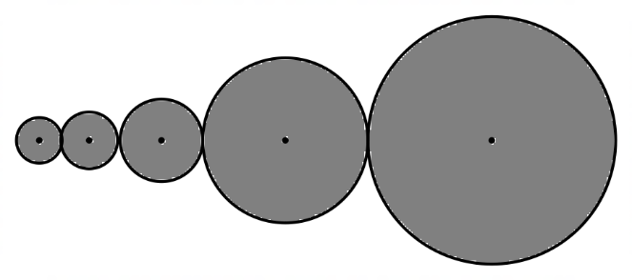

The radii of these circles form a geometric progression where the radius of the smaller circle is 3 units and that of the fifth (larger) circle is 48 units.

1. Find the common ratio of the geometric progression. (2 marks)

|  |
| --- |
| **Solution** |
|  |
|  |

The pattern is extended by 5 more circles to a total of 10 circles.

1. Determine the length added to the original value of *L.* (4 marks)

|  |
| --- |
| **Solution** |
|  |
| ✔✔ finding Lengths of 10 and 5 circles  ✔✔ finding additional length |

(b) Calculate, in terms of , the total area of the 10 circles of the new pattern. (4 marks)

|  |
| --- |
| **Solution** |
|  |
| ✔✔ expressing area as a sum of the geometric sequence  ✔✔ determining the area with correct unit ( |

**Question 12 (12 marks)**

On Phillip Island the number of hours of daylight in each day of the year varies from 10 hours to 14 hours over the 365 days in the calendar year.

The longest day of the year occurs 10 days before the beginning of the calendar year.

1. Write a trigonometric equation that will model the number of hours of daylight in each day of the year where is the hours of daylight and is the number of days after midnight from the start of the year. (4 marks)

|  |
| --- |
| **Solution** |
| or |
| ✔ vertical translation of 12 units  ✔ amplitude of 2  ✔ phase shift of 10  ✔ period of 365 |

1. How many hours of daylight are there on the first day of the year? (2 marks)

|  |
| --- |
| **Solution** |
| Let |
|  |

1. The prices of tourist accommodation in the island are highest when the hours of daylight per day are 13 hours or more. How many days after the beginning of the year does the high season end? (3 marks)

|  |
| --- |
| **Solution** |
| Solve for when |
| ✔ equating model to 13  ✔ determining  ✔ stating |

1. Philip Island Tourism tries to encourage visitors to the island during the winter months. They offer special deals for those visiting the island during the time of year when there are less than 11 hours of daylight. For how many days of the year are the special deals available to visitors? (3 marks)

|  |
| --- |
| **Solution** |
| Solve for when  Two points |
| ✔✔ stating two points where  ✔ stating 122 days |

**Question 13 (9 marks)**

A relay team of four runners is to be chosen from a training squad of eight runners. Assuming that all eight runners are of equal ability and have the same chance of being selected, find the following:

1. the number of different teams that can be selected. (1 marks)

|  |
| --- |
| **Solution** |
|  |
|  |

1. the probability that you will be chosen, supposing that you are one of the eight runners. (2 marks)

|  |
| --- |
| **Solution** |
|  |
|  |

1. Suppose that your friend is also one of the eight. What is the probability that you and your friend will be both selected? (2 marks)

|  |
| --- |
| **Solution** |
|  |
|  |

1. What is the probability of you or your friend being in the team? (2 marks)

|  |
| --- |
| **Solution** |
|  |
|  |

1. Given that the team chosen is one that your friend is in, what is the probability that you will also be included? ( 2 marks)

|  |
| --- |
| **Solution** |
|  |
|  |

**Question 14 (11 marks)**

A wire of total length is to be cut into two pieces for an art installation. The first piece is bent to form an equilateral triangle of side length and the second piece is bent to form a circular sector of radius The circular sector subtends an angle radians at the centre.

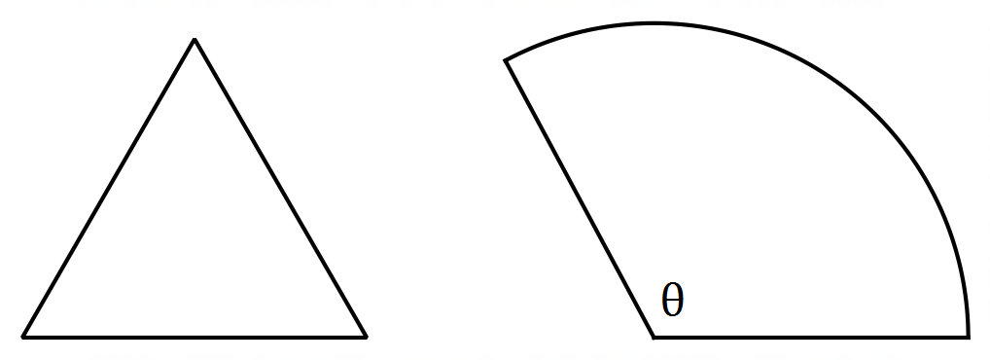

1. Show that (2 marks)

|  |
| --- |
| **Solution** |
|  |
| ✔ ✔ setting up the sum of the perimeter of the shapes equal to 120. |

(b) The total area of the two shapes is Show clearly that (4 marks)

|  |
| --- |
| **Solution** |
|  |
| ✔ setting up area for triangle  ✔ setting up area for sector  ✔✔ correct working out resulting to required equation for (-✔ for every error) |

1. Use a calculus method to find correct to three significant figures, the maximum value of , justifying the fact that it is indeed the maximum value of (5 marks)

|  |
| --- |
| **Solution** |
|  |
| ✔ finding derivative  ✔ setting derivative to  ✔ finding value for A  ✔✔ valid justification for A as the maximum area |

**Question 15 (9 marks)**

(a) Integrate with respect to x. Express your answer with exactly 4 terms and without any negative exponents. (3 marks)

|  |
| --- |
| **Solution** |
| +C |
| ✔ correct antiderivative  ✔ positive exponents  ✔ C |

(b) Justify the relevance of adding an arbitrary constant in finding the antiderivatives of functions. (1 mark)

|  |
| --- |
| **Solution** |
| Adding a constant C, accounts for the fact that there are families of curves which will have the same derivative. Unless we are given a point in the function, we can only write a general form for the antiderivative. |
|  |

(c) The figure below shows the curve which meets the coordinate axes at the points

and

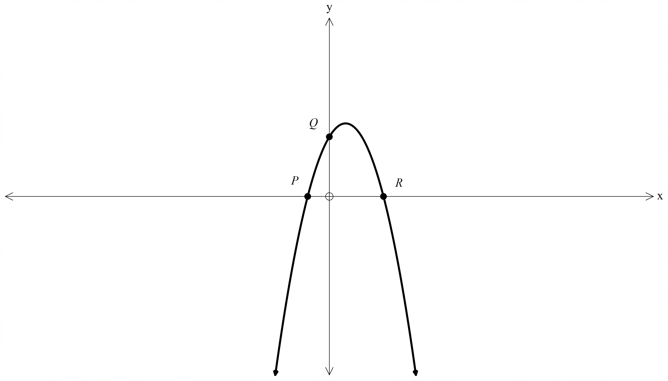



The gradient function of is given by and that determine the coordinates of the points and (5 marks)

|  |
| --- |
| **Solution** |
|  |
| ✔ finding the function  ✔ correct value for c  ✔✔✔ coordinates for |

**END OF SECTION 2**

Additional working space

Question number:

Additional working space

Question number:

Additional working space

Question number: